
Experiment 5: Cloud Migration - Backup Setup experiment using Google Drive as the cloud storage service.
AIM:
To create a cloud backup system by storing important files in Google Drive, scheduling automatic backups, and verifying successful backup completion.
PROCEDURE:
- Create a folder named OfficeData on the Desktop.
- Create three text files Student.txt, Attendance.txt, and Marks.txt inside the OfficeData folder and add sample data.
- Open Google Drive and log in using the Google account.
- Create a folder named CloudBackup in Google Drive.
- Upload the three text files into the CloudBackup folder.

- Download and install Google Drive for Desktop and log in with the same Google account.
- In Google Drive settings, select the OfficeData folder and enable Sync with Google Drive.
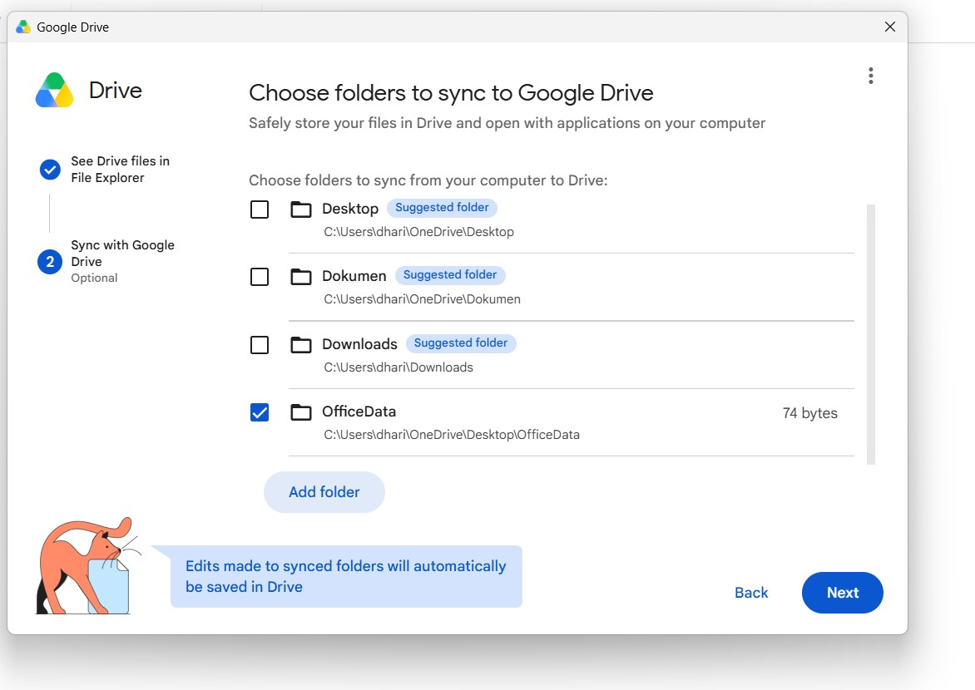
- Verify that the OfficeData folder and its three files are synchronized with Google Drive.
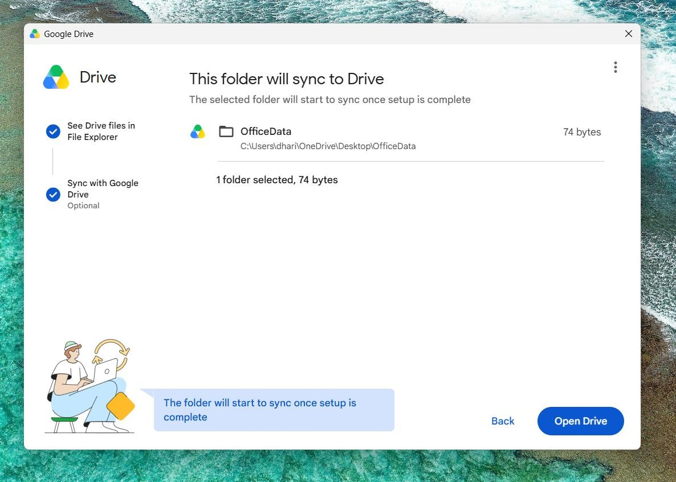
- Modify Student.txt by adding the line “Cloud Backup Test - Successfully Synchronized” and save the file.
- Wait for synchronization and verify the “Up to date” or “Successfully uploaded” status.
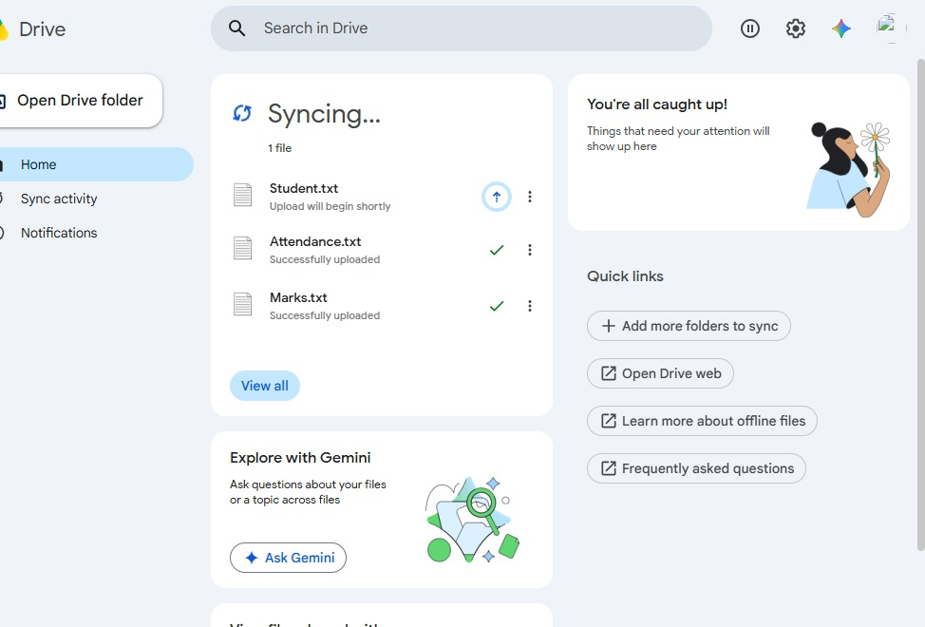
- Open Google Drive Web, open Student.txt, and verify that the updated content is reflected in the cloud.
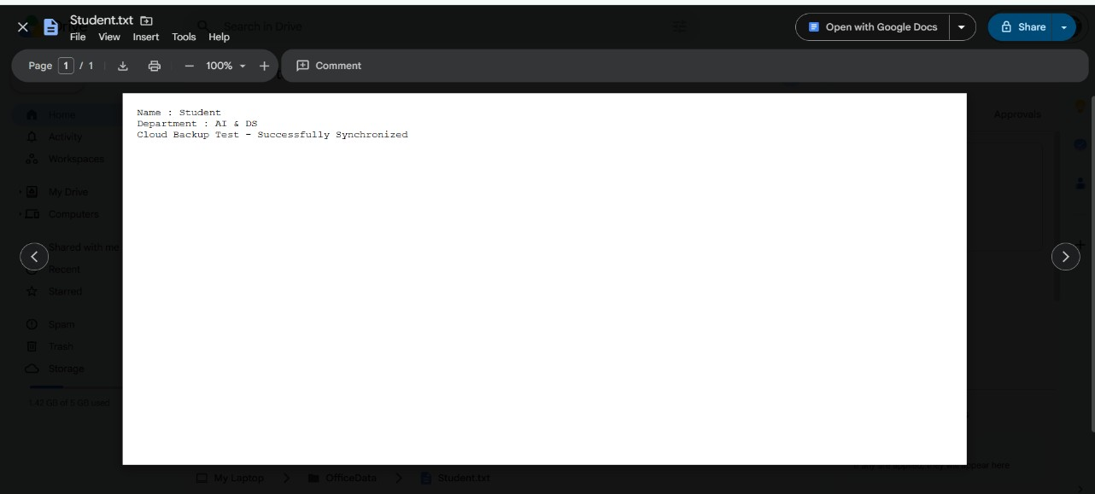

CONCLUSION:
The cloud backup system was successfully implemented using Google Drive. The local files were migrated to cloud storage, automatic synchronization was enabled, and the updated file was successfully synchronized and verified in Google Drive. Thus, an effective cloud backup mechanism was demonstrated.

